**An Overview of the English Verb System**

UNIT 1: Time and tense

**GOALS:**

* To review the English verb system
* To keep tenses in the same time frame
* To change the time frame correctly with a passage

**Opening task**

Comparing past, present and future

Step 1 Work with a partner. Student A, look at the following information about

Slava Shutov, a typical Russian university graduate. Student B, look at

the information about Slava’s grandfather, Geliy Chirkov. Student A, tell

Student B about Slava’s life. Student B, tell Student A about Geliy’s life.

**SLAVA SHUTOV**

**Born:** 1995

** Family:** a younger sister, living with her parents in

Pechora; Slava lives alone in St. Petersburg

**Occupation:** has a degree in IT but doesn’t know why;

works as a comedian (clown)

**Regular activities:** working and trying not to set his kitchen on

fire while cooking

**Hobbies or favorite sports:** playing chess, videogames,

basketball; watching Netflix

**Visits to foreign countries:** Spain, Germany, Turkey, Cyprus

**Special skills or abilities:** comes up with good puns (sometimes)

**Probable activity at this moment:** procrastinating

**GELIY CHIRKOV**

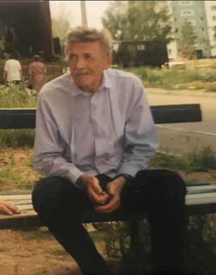 **Born:** 1935 **Died:** 2021

**Family:** one older brother and a younger sister; his mother died at

the age of 92

**Occupation:** painter and designer; graduated from high school with

a red diploma

**Regular activities:** painting and mushroom hunting

**Hobbies or favorite sports:** watching TV, writing poetry,

sightseeing

**Special skills or abilities:** incredibly intelligent

**Probable activity when Slava was born:** decorating buildings

and factories in Vorkuta

Step 2 Now work together to create a story for Fregonia, Slava’s granddaughter.

Fill in some information below and then tell another pair of students about

what you think Fregonia’s life will be like.

**FREGONIA YEVGENIEVNA MIRONOVA**

**Born:** 2055

 **Family:** _________________________________________

**Occupation:** ______________________________________

**Regular activities:** _________________________________

________________________________________________

**Hobbies or favorite sports:** __________________________

________________________________________________

**Visits to foreign countries or planets:** __________________

_ _______________________________________________

**Special skills or abilities:** ___________________________

________________________________________________

**Probable activity at this moment 100 years from today:** ___

________________________________________________

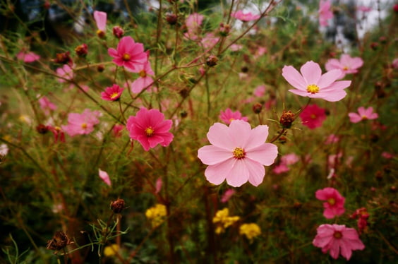

FOCUS **1**

**The English verb system at a glance**

The form of any verb in English is made up of two things: time frame and aspect.

|  |  |
| --- | --- |
| **Time frame** tells **when** something took place. There are three basic time frames: **present**, **past** and **future**. | **Aspect** tells **how** the verb is related to that time, or gives some other information about the quality of the action. |

There are four kinds of aspect, and each one has a basic meaning.

|  |  |
| --- | --- |
| **ASPECT** | **MEANING** |
| simple | **at** that time |
| progressive | **in progress during** that time |
| perfect | **before** that time |
| perfect progressive | **in progress during and before** that time |

When we combine the three time frames and the four aspects, we get twelve possible combinations of forms. These forms are called *tenses*, and the name of each tense tells which time frame and which aspect are being used.

|  |  |  |  |  |  |  |
| --- | --- | --- | --- | --- | --- | --- |
| **ASPECT** | | **SIMPLE** | **PROGRESSIVE** | **PERFECT** | | **PERFECT PROGRESSIVE** |
| TIME FRAME TENSES | | | | | | |
| **Present** | *simple present*  study/studies  give/gives | | *present progressive*  is/are studying  is/are giving | | *present perfect*  has/have studied  has/have given | *present perfect progressive*  has/have been studying  has/have been giving |
| **Past** | *simple past*  studied  gave | | *past progressive*  was/were studying  was/were giving | | *past perfect*  had studied  had given | *past perfect progressive*  had been studying  had been giving |
| **Future** | *“simple future”*  will study  will give | | *future progressive*  will be studying  will be giving | | *future perfect*  will have studied  will have given | *future perfect progressive*  will have been studying  will have been giving |

**EXERCISE 1**

Read the following passages and identify the time frame of each. Is it present time, past time, or future time?

1. (a) Denis had a terrible headache. (b) His throat was dry, and his eyes were burning. (c) He had been sneezing constantly for nearly an hour. (d) He hated late summer. (e) For most people, this time of year meant flowers and sunshine, but for Denis it meant allergies.
2. (a) I really don’t know what to do for vacation. (b) My vacation starts in three weeks, and (c) I’m trying to decide what to do after exams are over. (d) I’ve been to Murmansk and Novosibirsk. (e) It’s too early in the year to go camping in the mountains. (f) I’ve been studying hard lately, and I really need to get away. (g) I’ve saved enough money to have a wonderful trip. (h) I just can’t decide where to go or what to do.
3. (a) The changing world climate will mean changes in food production. (b) Scientists think that summers throughout Russia will become much hotter and drier than they are now. (c) Crops that require a lot of water will be less economical to grow. (d) Society will have to develop different energy sources, (e) since fossil fuels, such as coal and oil, may have become depleted by the end of this century.
4. (a) “Social Darwinism” was a popular theory of the nineteenth century. (b) It compared social and economic development with biological evolution. (c) According to this theory, competition between rich people and poor people was unavoidable. (d) The poor were like dinosaurs who were dying out because they had lost the battle for survival – economic survival.
5. (a) Scientific research often has an important social impact. (b) In recent years scientists have discovered that Vitamin B can prevent certain kinds of childhood blindness. (c) As a result, programs have been established that provide education and dietary supplements to children in developing countries.

**EXERCISE 2**

Choose three of the passages in Exercise 1, and underline each complete verb phrase (the verb plus any auxiliary – *have, do, is,* etc. – that shows the tense of the verb). Name the tense of each verb phrase you have underlined.

**EXERCISE 3**

How well do you know the irregular verb forms? Check by completing the charts on pages 24-26 and doing the exercises on the following pages.

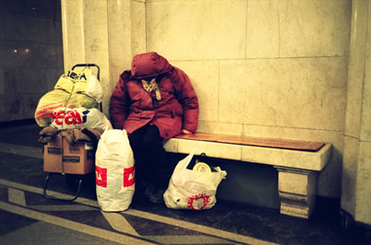

FOCUS **2**

**Keeping tenses in the same time frame**

In general, we choose a particular time frame and then choose from among the tenses within that time frame in order to describe events.

|  |  |
| --- | --- |
| **EXAMPLES** | **EXPLANATIONS** |
| 1. My roommate **had** a dance party last Friday night. I **was working** that night, so I **didn’t get** home until 10:00, and everyone **had** already **started** dancing. | Use past tenses to describe things that happened at a specific time in the past. |
| 1. My roommate **has** a dance party every Friday night. I **work** on Friday nights, so I **don’t get** home until 10:00, and everyone **has** already **started** dancing. | Use present tenses to describe things that are happening now, are related to now, or happen again and again. |
| 1. My roommate **is going to have** a dance party next Friday night. I **will be working** that night, so I **won’t get** home until 10:00, and everyone **will** already **have started** dancing. | Use future forms and tenses to describe events that are going to happen at some time in the future. |

**EXERCISE 4**

Decide what time frame each of these passages should be written in, and the write the appropriate verb form in the blanks.

1. I hear we (a) ___________ (be playing) games at Sasha’s party next week. I hope there (b) ___________ (be) dancing and singing as well. I (c) ___________ (have completed) my dance classes by then, and I (d) ___________ (like) to sing and play the guitar.
2. I (a) ___________ (have) an interesting experience yesterday afternoon as I (b) ___________ (fly) back to St. Petersburg. I (c) ___________ (have) a seat next to someone I (d) ___________ (have gone) to school with. We (e) ___________ (have not seen) each other for a couple of years and we (f) ___________ (have) a lot to talk about.
3. Pasha (a) ___________ (have) a terrible time getting to the university every day. When he (b) ___________ (be driving), he often (c) ___________ (get) caught in huge traffic jams. Even though he (d) ___________ (live) only a few kilometers from the university, it sometimes (e) ___________ (take) nearly an hour to get there.
4. The Imperial City of Rome (a) ___________ (be) badly damaged by fire during the First Century A.D. At the time, it (b) ___________ (be believed) that the Emperor Nero (c) ___________ (be playing) a violin while the city (d) __________ (burn) to the ground.
5. Scientists (a) ___________ (be) worried that the world climate (b) ___________ (be changing). They (c) ___________ (believe) this change (d) ___________ (have resulted) from an increase in the amount of carbon dioxide in the earth’s atmosphere. Whenever fossil fuels such as coal or oil (e) __________ (be burned), the amount of carbon dioxide (f) ___________ (increase). This (g) ___________ (cause) the atmosphere to retain more heat. There (h) ___________ (be) proof that this process (i) ___________ (have already begun). Scientists (j) ___________ (have discovered) that the average temperature of the world’s oceans (k) ___________ (have risen) by one degree in the last twenty years.
6. Slava (a) ___________ (leave) for Pechora on Tuesday. He (b) ___________ (be staying) with a local family (his own) for the first few weeks. After that, he (d) ___________ (probably find) a small apartment somewhere along the river, so that he (d) ___________ (go) fishing every day.

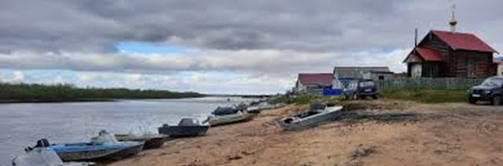

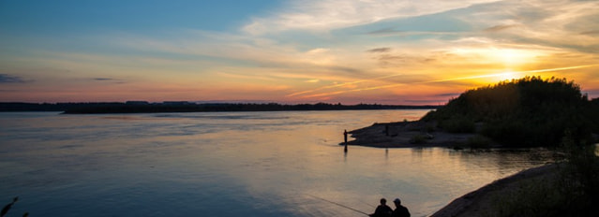

FOCUS **3**

**Changing the time frame within a passage**

|  |  |
| --- | --- |
| **EXAMPLES** | **EXPLANATIONS** |
| 1. There **are** many examples in history of increasing military power causing a decreasing standard of living. Rome **was** unable to feed both its army and its population. And Great Britain **declined** steadily from its economic position in the early part of this century. | * to move from a general statement to specific examples |
| 1. **One hundred years ago** the life expectancy in the United States **was** about sixty-five. **Now**, it **has increased** by an average of ten years. **In the next century**, if current trends continue, people **should be able to live** until their nineties. Interestingly enough, however, **a hundred years ago** the number of people who were over one hundred **was** less than one percent of the population. That figure **has not changed** substantially, even **today**. | * to show a contrast between one time and another |
| 1. I saw an elderly lady yesterday. **You don’t see her kind much anymore**. She was wearing a black dress and she was carrying an umbrella. **Most elderly ladies I know don’t carry umbrellas, and pants are more common than dresses**. As she walked down the street, I thought about how much life has changed since she was my age. | * to make a statement of general truth |

**EXERCISE 5**

Mark the following passages with a slash (/) to show where the time frame changes. The first one has been done for you as an example.

1. My brother called me yesterday. / I always know he needs to borrow money when he calls, because I never hear from him at any other time. / We spoke about this and that for a few minutes. He asked about my job and my family. We talked about his problems with his boss. / These are typical topics before he finally asks for a loan. / This phone call was no exception. He needed fifty dollars “until payday”. / Somehow, when payday comes he never remembers to pay back the loan.
2. I’ll be really happy when the summer is over. I don’t like hot weather, and I can’t stand mosquitoes. There’s a lot of both in the summer. Last summer I tried to escape by going on a trip to Apatity. The heat wasn’t bad, but the mosquitoes were ferocious! Next year I think I’ll consider a vacation in Antarctica. I understand it’s not very hot there in July.
3. For almost a hundred years, scientists around the world have all used a single system to measure the strength (or “magnitude”) of earthquakes. The Richter Scale was developed by Charles Richter in 1935. It was designed so scientists could compare the strength of earthquakes in different parts of the world. It was not designed to measure damage in earthquakes, only intensity. This is because a less powerful earthquake in a heavily populated area can cause more damage than a stronger earthquake in an unpopulated area.

**EXERCISE 6**

Discuss the changes of time frame that you found in the previous exercise with a partner. Why did the author make each of them? There may be more than one reason. Share your explanation with the rest of the class.

**EXERCISE 7**

Underline the complete verb phrases (verb plus auxiliaries) in the passages in Exercise 5 and name the tense of each verb phrase.

Use your English

**ACTIVITY 1: SPEAKING / WRITING**

Step 1 Work with a partner. Describe a typical day in your life. Tell your

partner about the things you do, where you go, and how you typically

spend your time. Mention at least five regular activities.

Step 2 Next, describe a typical day in your life five years ago. Mention at least

five activities that you did on a regular basis.

Step 3 Your partner should use this information to decide what three things in

your life have changed the most in the last five years, and report this

information to the rest of the class. Make a similar report to the class

about the changes in your partner’s life.

**ACTIVITY 2: LISTENING**

Listen to these descriptions about two people – one who is no longer living and one who is still alive. Based on the time frame and verb tenses used in the descriptions, decide which person is still living and which person is not.

**ACTIVITY 3: SPEAKING / WRITING**

Congratulations! You’ve just won a million dollars in a contest. BUT…you have to spend all the money in a single week. AND…you can’t spend more than $50,000 for any single purchase. (In other words, you can’t just buy a million dollar house. You have to make at least twenty separate purchases.) If you don’t spend it all, you won’t get any of it.

Step 1 What are your plans? In a brief essay, or in an oral presentation, answer

this question: **How will you spend the money?**

Step 2 It’s the end of the week. Change the verb tenses of your essay or

presentation to answer this questions: **How did you spend the money?**

**ACTIVITY 4: WRITING / SPEAKING**

Newspaper headlines represent a special kind of English. They usually omit a lot of important grammatical information. Test how well you know the basic sentence elements of English by “translating” these headlines into complete sentences. Compare your “translations” to those of another student.

**EXAMPLE:** BABY FOUND IN BUS STATION

A baby has been found in the bus station

|  |  |
| --- | --- |
| * NEVSKY PROSPECT TO BE CLOSED FOR VICTORY DAY PARADE * SCORCHING HOT SUMMER TEMPS ROAST RUSSIAN CITIES * NEW BUDGET TERMED “’DISASTER” * PRESIDENT TO VISIT CHINA * DROUGHT EXPECTED TO WORSEN | * NEW PLAN TO IMPROVE CITY BUS SERVICES * MAJOR GROWTH IN INTERNATIONAL STUDENTS IN RUSSIA * POPLAR FLUFF COVERS CITY STREETS * EGE TEST SCORES IMPROVING * CYCLIST CROSSES HALF OF RUSSIA IN 48 DAYS |

UNIT 2: Aspect

**GOALS:**

* To review aspect in English verbs
* To review the simple tenses
* To use progressive, perfect, and perfect progressive aspect appropriately

**Opening task**

Happenings past, present and future

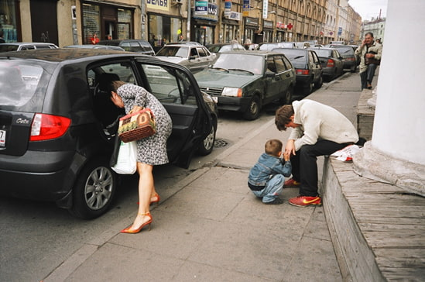

Step 1 With a partner, discuss each of these photographs and together write

sentences about them. Your sentences should answer these questions.

* What has just happened? Why do you think so?
* What is happening now? Why do you think so?
* What is going to happen next? Why do you think so?

Step 2 Once you have described all the pictures, compare your descriptions with

another pair of students. Do you all agree? Did you use the same tenses

in your descriptions?

Step 3 Report any interesting similarities and differences to the rest of the class.

Then go through the same procedure with the photographs on pages 4, 18,

19, 23 and 26.

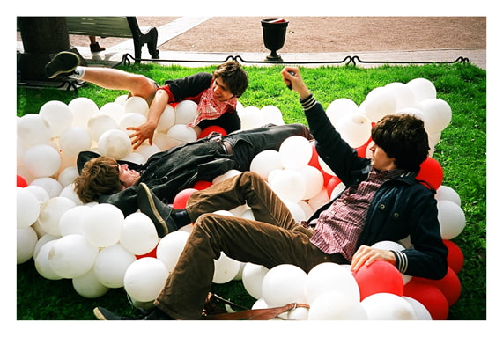

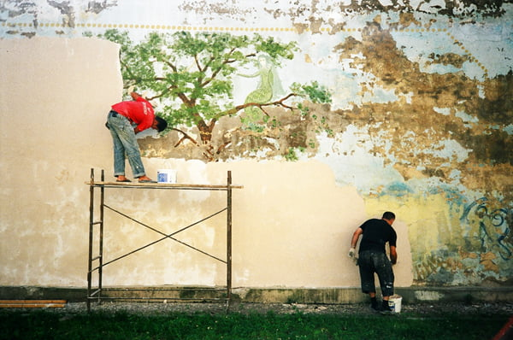

FOCUS **1**

**An overview of aspect**

In addition to the basic meanings of aspect listed in UNIT**1**, aspect can also be used to describe the quality of an action or situation.

|  |  |
| --- | --- |
| **EXAMPLES** | **EXPLANATIONS** |
| (a) The protester **disrupted** the  politician’s speech. | * action happens just once |
| (b) Protesters **have been disrupting**  politician’s speeches as long as  politicians **have been making**  them. | * action happens continuously or repeatedly |
| (c) The police **are arresting** the  protester, but perhaps he’ll  escape. | * action is still happening |
| 1. The police **have arrested** the protester, so he won’t be able to escape. | * action is completed |
| 1. Shopkeepers **are storing** some of their breakable items on the floor until the threat of earthquake after-shocks has passed. | * situation is temporary |
| 1. Shopkeepers in areas where there are earthquakes **store** expensive, breakable items on the lower shelves in order to lessen the possibility of damage. | * situation is permanent |

**EXERCISE 1**

Analyze these paragraphs with a partner. Identify the basic time frame. Then say what meaning is contributed by the aspect in the underlined verb phrases.

1. By the time Slava gets on Flight 53 to Pechora the day after tomorrow, he will have accomplished a great deal in a short period of time. He will have moved out of the apartment where he has been living for the last couple of years. He will have said some long, sad good-byes, and he will certainly be thinking about all the friends he will no longer see every day.
2. When the earthquake hit San Francisco in 1989, Jeff was still at his office. He had been trying to finish a project. He had been working on it for over a week, and he was almost done. He was just making some final changes when the building started to move. When the quake started, he quickly got under his desk. He was glad that he had once read an article on what to do in earthquakes. He had studied the article carefully, so he knew exactly what to do.
3. Nancy is quite a stylish dresser. She thinks that it is important to be neat and well-dressed, and she always wants to look her best. Every morning before she leaves for work, she looks at herself in the mirror. She checks to make sure that she has combed her hair and hasn’t put her makeup on too heavily. She makes sure that she is wearing colors that go nicely with the clothes she is wearing. She checks to see that her slip isn’t showing and her stockings are straight. She makes sure that the shoes she has chosen match the color of her dress and her coat. She likes feeling confident and attractive, and feels that taking an extra minute in front of the mirror is worth the time.

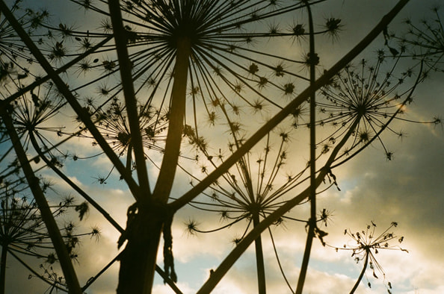

FOCUS **2**

**Simple tenses**

|  |  |
| --- | --- |
| **EXAMPLES** | **EXPLANATIONS** |
| (a) Social psychology **is** the study of  the factors that **influence** group behavior.  (b) The people of ancient Rome **spoke** Latin.  (c) A criminal **will** always **return** to the  scene of the crime. | Use simple tenses   * to express general ideas, relationships, and truths |
| (d) Denise always **checks** her appearance  in the mirror before she leaves for work.  (e) James Fenimore Cooper **wrote** for three  hours every day except Sunday.  (f) People **will commute** to the moon by  spaceship at the end of this century. | * to describe habitual or recurrent actions |
| (g) Scientists **report** that they have identified  a new planet that might have what it  takes to sustain life.  (h) When Alexander the Great **decided** to  conquer Asia, he had already heard many  stories about the great riches there.  (i) Masha **will visit** Slava while he is  fishing in Pechora. | * to identify time frame |
| (j) Nikita **worries** that he won’t pass his  programming exam.  (k) One hundred years ago people **felt** that a  woman’s place was in the home.  (l) If we’re late for dinner, Mom **will worry**  about us. | * to describe mental perceptions or emotions |
| (m) Slava **has** a sister.  (n) Geliy’s hobbies **consisted** of watching  TV, writing poetry and sightseeing  (o) Fregonia’s job **will require** regular  travel to Mars. | * to express possession or logical relationship |

**EXERCISE 2**

Work with the same partner that you did for the opening task. But instead of describing Slava Shutov and his family, describe your own lives, and those of your grandfathers and what may be true for your granddaughters. Each of you should write at least two sentences that describe the lives of each generation.

FOCUS **3**

**Progressive aspect**

Progressive tenses (present progressive, past progressive, and future progressive) are made by using forms of

**BE + VERB + ING**

|  |  |
| --- | --- |
| **EXAMPLES** | **EXPLANATIONS** |
| (a) Other people **are** always **waiting** when  Kirill **gets** to the bus stop. (They’re  already waiting **before** he gets there.)  (b) Kirill **reads** his favorite news app when  he **gets** to the bus stop. (He reads his  news app **after** he gets there.)  (c) When he **entered** the room, the other  students **were studying**, but when he left  the room, they all **laughed**. (They **were**  **studying** **before** he entered, but they  laughed **after** he left.) | Use progressive aspect instead of simple aspect to describe   * actions already in progress versus actions that happen afterwards |
| (d) I **teach** English, but I**’m not teaching** at  the moment.  (e) Danya **studied** in Korea for a semester,  but he certainly **wasn’t studying** last  New Year’s Eve. | * actions at a specific time (**now** or **then**) versus habitual or recurring actions |
| (f) Masha still **lives** with her parents, but  she**’s staying** with friends while her  parents are away. | * temporary situations versus permanent states |
| (g) Those students **are** always **asking**  questions. | * repeated actions |
| (h) Ahmed **is** still **working** to perfect his  Cockney accent. | * uncompleted actions |
| (i) Those children **are being** very noisy, but  they **are** young, so it’s understandable. | * actions rather than states |

**EXERCISE 3**

Why is progressive aspect used in these sentences? There may be more than one reason.

› Example: He is studying for an examination now.

action in progress now, uncompleted action

* 1. Andrey was reading a book when I saw him.
  2. Don’t call him after 11:00 because he will be sleeping.
  3. They were going from shop to shop yesterday afternoon and selling homemade greeting cards.
  4. Whenever I see Andrey, he is always reading a book.
  5. I will be visiting friends all over the country during the summer.
  6. Andrey was thinking about a solution to his problem, so I didn’t distract him.
  7. He was living with his cousin for a while.
  8. I am having trouble with this assignment.
  9. I will be staying with some friends during the conference.
  10. I am trying to explain this, so please pay attention.

**EXERCISE 4**

Decide whether simple or progressive aspect should be used in these sentences. Both choices may be correct.

1. Please turn down the music. I ___________ (study) for a test.
2. Afanasy ___________ (read) an email when his phone rang.
3. I’m afraid those students might (a) ___________ (get) in trouble with their teacher because they (b) ___________ (skip) too many classes.
4. I still ___________ (not study) as much as my parents want me to.
5. Katya ___________ (speak) Russian. I wonder where she learned it.
6. Columbus (a) ___________ (look) for a shorter route to Asia when he (b) ___________ (discover) the New World by mistake.
7. When Columbus (a) ___________ (reach) Cuba, he (b) ___________ (think) it was India.
8. I ___________ (try) to help you. Please listen carefully.
9. I (a) ___________ (study) in the library when I (b) ___________ (hear) the news about our exam.
10. Dasha will probably ___________ (sleep) if you wait until midnight to call her.

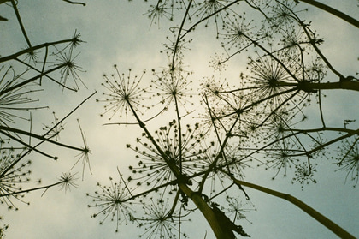

FOCUS **4**

**Perfect aspect**

Perfect tenses (present perfect, past perfect, and future perfect) are made by using forms of

**HAVE + VERB-EN (past participle)**

The basic meaning of the perfect aspect is this: the action described using the perfect aspect began before other action or another point in time, and it continues to have influence. We do **not** use perfect aspect to connect unrelated events.

|  |  |
| --- | --- |
| **EXAMPLES** | **EXPLANATIONS** |
| (a) He **had finished** the project when I **talked**  to him. (The project was finished before I  talked to him.)  (b) He **finished** the project when I **talked** to  him. (I talked to him first, and then he  finished the project.) | Use perfect aspect instead of simple aspect to describe actions   * that happen before another action |
| (c) We have an English test tomorrow. I  **have** **reviewed** the vocabulary words, but  I **haven’t studied** the grammar yet. | * that focus on whether they are completed or uncompleted |
| (d) I **have finished** my homework so now  I’m playing video games.  (e) Anya **has** just **had** a snack, so she  doesn’t want dinner. | * that are related to the present moment |
| (f) Robert Lee **has worked** in a factory for  thirty-five years. (He still works there.)  (g) Robert Lee **worked** in a factory for  thirty-five years. (He doesn’t work there  anymore.) | * that began in the past but still continue until now |

**EXERCISE 5**

Why is perfect aspect used in these sentences? There may be more than one reason.

1. Please don’t take my plate. I haven’t finished my dessert.
2. You are too late: the doctor has just left the office.
3. He had forgotten to leave a key, so we couldn’t get into the office.
4. She will already have left before you receive her message.
5. I’ve done my homework for tomorrow.
6. Sasha hadn’t even finished the university when he got a full-time job.
7. The teacher has canceled the test, so you won’t need to study tonight.
8. It has snowed every January for the last ten years, so I don’t think it’s a good idea to plan a picnic.

**EXERCISE 6**

Decide whether perfect or simple aspect should be used in these sentences.

1. Slava ___________ (say) goodbye to his co-workers when he started packing for his trip to Pechora.
2. Jonas Salk ___________ (conduct) many unsuccessful experiments when his efforts finally resulted in the discovery of a vaccine for polio.
3. The United States ___________ (have) the same form of government for more than two hundred years.
4. Tanya ___________ (visit) Voronezh five times so far. She really likes traveling there.
5. When Nikita first (a) ___________ (come) to St. Petersburg, he

(b) ___________ (not be) away from his parents for more than a few days.

1. By the time Fregonia is fifty years old, she will probably __________ (travel) to Mars several times.
2. I ___________ (not sleep) well since those noisy people moved into the apartment next door.
3. Columbus (a) ___________ (complete) three voyages to islands in the Caribbean when he (b) ___________ (realize) that the islands (c) ___________ (not be) part of India.
4. We ___________ (live) in this apartment since 1988.
5. Nastya ___________ (study) very hard for her exam, so I hope she passes it.

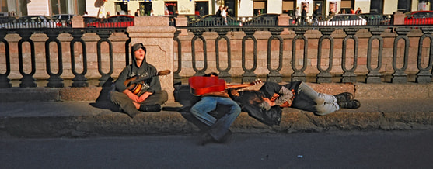

FOCUS **5**

**Perfect progressive aspect**

Perfect progressive tenses (present perfect progressive, past perfect progressive, and future perfect progressive) are made by using forms of

**HAVE + BEEN + VERB + -ING**

|  |  |
| --- | --- |
| **EXAMPLES** | **EXPLANATIONS** |
| (a) Slava has been working on that project all  day. He still hasn’t finished it.  (b) Slava has worked on that project for three  hours. Now he can do something else. | Use perfect progressive aspect instead of perfect aspect to describe   * actions that are uncompleted (a) instead of completed (b) |
| (c) You have been talking for the last twenty  minutes straight. Why don’t you give  somebody else a chance to say what they  think?  (d) I have talked to that student several times  about his lackadaisical attitude. | * actions that are continuous (c) instead of repeated (d) |

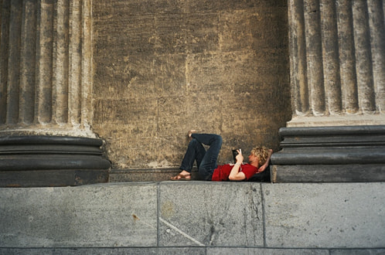

**EXERCISE 7**

Decide whether perfect or perfect progressive aspect should be used in these sentences. More than one answer may be correct.

1. It ___________ (rain) ever since we got here. I wish it would stop.
2. He ___________ (work) on that computer virus for nearly a year before he realized that nothing could destroy it.
3. I’m very pleased. I ___________ (find) the article you mentioned in your paper.
4. Lately Slava ___________ (find) life without Masha more and more difficult.
5. Arina ___________ (cook) all afternoon. I hope the food will taste as good as it smells.
6. Nikita (a) ___________ (look) for his keys for over an hour when he realized that he (b) ___________ (leave) them in his coat pocket.
7. I ___________ (try) to solve this problem for over an hour. I give up!
8. Next January 1, Nastya and Asya ___________ (live) together as roommates for three years.
9. That woman (a) ___________ (come) to the market to sell her vegetables and herbs ever since I (b) ___________ (move) into the neighborhood.
10. I ___________ (try) to reach him several times by phone, without success.

**EXERCISE 8**

Write the appropriate form for the verbs in the following paragraph. The first three have been done for you as examples.

My roommate (1) ___had_____ (have) a dance party last Friday night. I (2) __was working__ (work) that night, so I (3) __didn’t get__ home until 10:00. By the time I (4) ___________ (get) there, everyone (5) ___________ (start) dancing. When I (6) ___________ (walk) into the room, everybody (7) ___________ (shout) “Welcome home!” because I (8) ___________ (just arrive), and they (9) ___________ (keep) dancing. I (10) ___________ (go) into the kitchen to find something to eat. There (11) ___________ (be) several other people there, and they (12) ___________ (sit) by an open window. We (13) ___________ (talk) and (14) ___________ (laugh) for a while. Just when I (15) ___________ (be) ready to start dancing myself, there (16) ___________ (be) a knock at the door. I (17) ___________ (go) to answer it, and (18) ___________ (discover) our neighbor, who (19) ___________ (complain) about the noise. He (20) ___________ (ask) us to turn the music down. We (21) ___________ (obey), of course, and although the party (22) ___________ (get) a little quieter, we still (23) ___________ (have) fun.

**EXERCISE 9**

Rewrite the paragraph in Exercise 8 in a present time frame. Keep the time relations between the verbs the same by maintaining the same aspect differences.

My roommate (1) ___has_____ (have) a dance party every Friday night. I (2) __am working__ (work) Friday nights these days, so I (3) __don’t get__ home until 10:00. On most Fridays, by the time I (4) ___________ (get) there, everyone (5) ___________ (start) dancing. When I (6) ___________ (walk) into the room, everybody (7) ___________ (shout) “Welcome home!” because I (8) ___________ (just arrive), and they (9) ___________ (keep) dancing. I generally (10) ___________ (go) into the kitchen to find something to eat. Usually, there (11) ___________ (be) several other people there, and they (12) ___________ (sit) by an open window. We (13) ___________ (talk) and (14) ___________ (laugh) for a while. Just when I (15) ___________ (be) ready to start dancing myself, there (16) ___________ (be) almost always a knock at the door. I (17) ___________ (go) to answer it, and (18) ___________ (discover) our neighbor, who (19) ___________ (complain) about the noise. He (20) ___________ (ask) us to turn the music down. We (21) ___________ (obey), of course, and although the party (22) ___________ (get) a little quieter, we generally still (23) ___________ (have) fun.

**EXERCISE 10**

Now rewrite the paragraph in Exercise 8 in a future time frame. Keep the time relations between the verbs the same by maintaining the same aspect differences.

My roommate (1) _is going to have_ (have) a dance party next Friday night. He has done this so often that I think I know exactly what’s going to happen. I (2) _will be working_ (work) next Friday night, so I (3) __won’t get__ home until 10:00. By the time I (4) ___________ (get) there, I’m sure that everyone (5) ___________ (start) dancing already. When I (6) ___________ (walk) into the room, everybody (7) ___________ (shout) “Welcome home!” because I (8) ___________ (just arrive), but they probably (9) ___________ (keep) dancing. I probably (10) ___________ (go) into the kitchen to find something to eat. Undoubtedly there (11) ___________ (be) several other people there, and they (12) ___________ (sit) by an open window. If next Friday is like most Fridays, we (13) ___________ (talk) and (14) ___________ (laugh) for a while, and just when I (15) ___________ (be) ready to start dancing myself, there most likely (16) ___________ (be) a knock at the door. I (17) ___________ (go) to answer it, and (18) ___________ (discover) our neighbor. He (19) ___________ (complain) about the noise and (20) ___________ (ask) us to turn the music down. We (21) ___________ (obey), of course, and although the party (22) ___________ (get) a little quieter, we undoubtedly (23) ___________ (still have) fun.

**EXERCISE 11**

Work with a partner. Compare the tenses you used in Exercises 8, 9, and 10. Did you use the same aspect for each verb in all three exercises? What does this tell you about how tenses work together in a particular time frame? Discuss these questions with your partner, and report your ideas to the rest of the class.

**EXERCISE 12**

Complete these sentences with information about yourself. Compare your answers with those of other students. Did you use the same verb forms?

1. Until I started studying at this university …
2. I often think about my problems when …
3. I had never seen … before I …
4. The next time I see my family they …
5. I am usually unhappy if …
6. When I was growing up, I …
7. I have been studying English since I …
8. Lately I …
9. Once I have completed my education, I …
10. I have never … but I plan to do it someday.

Use your English

**ACTIVITY 1: LISTENING**

Listen to the following conversations and put a check next to the statements which can be correctly inferred from each conversation.

**Conversation 1**

_____ (a) Mary doesn’t want a roommate.

_____ (b) Mary doesn’t have a roommate at the moment, but she’s looking for one.

_____ (c) John doesn’t want a roommate.

_____ (d) John doesn’t have a roommate at the moment, but he’s looking for one.

**Conversation 2**

_____ (a) Peter is looking the contract over at this moment.

_____ (b) Peter is not looking the contract over at this moment.

_____ (c) Denise is looking the contract over at this moment.

_____ (d) Denise is not looking the contract over at this moment.

**Conversation 3**

_____ (a) The janitor finished washing the floors before Angela’s arrival.

_____ (b) He finished washing the floors after Angela’s arrival.

_____ (c) The janitor emptied the trash before Angela’s arrival.

_____ (d) He emptied the trash after Angela’s arrival.

_____ (e) The janitor finished the windows after Angela’s arrival.

_____ (f) He finished the windows after Angela’s arrival.

**Conversation 4**

_____ (a) Bob works at the steel mill now.

_____ (b) Bob doesn’t work at the steel mill now.

_____ (c) Dave works at the steel mill now.

_____ (d) Dave doesn’t work at the steel mill now.

**ACTIVITY 2: WRITING**

Revise your descriptions of the photographs in the Opening Task on pages 10 and 11 – and also on pages 4, 18, 19 and 23 – by using the past time frame. Start your descriptions like this: *When this picture was taken…*

**ACTIVITY 3: SPEAKING**

Find or bring in three interesting photographs. Make a brief presentation about them to the class. Describe what is happening, what has happened, and what is going to happen. Then give three reasons why you think each photo is interesting.

**ACTIVITY 4: WRITING / SPEAKING**

Describe a routine that you typically follow. Then describe one time when you did not follow that routine, and tell what happened. For example, perhaps you usually take a bus to the university. What time do you get there? What are people on the bus doing when you get on? What happened on the day when you decided to walk to the university, or when your friend offered to give you a ride to the university on their new scooter?

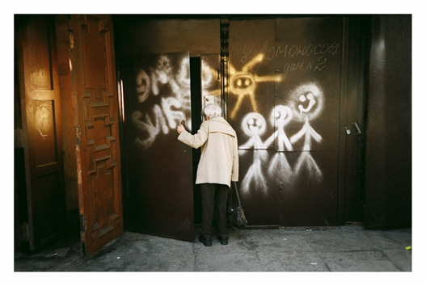

**Irregular verbs**

|  |  |  |
| --- | --- | --- |
| **Base form** | **Past tense form** | **Past participle** |
|  |  | become |
| begin |  |  |
|  | bent |  |
|  |  | bet |
| bind |  |  |
|  | bit |  |
|  |  | bled |
| blow |  |  |
|  | broke |  |
|  |  | brought |
| build |  |  |
|  |  | bought |
| catch |  |  |
|  | chose |  |
| come |  |  |
|  | cost |  |
| cut |  |  |
|  |  | dug |
| do |  |  |
|  | drew |  |
|  |  | drunk |
| drive |  |  |
|  | ate |  |
|  |  | fallen |
| feed |  |  |
|  | felt |  |
|  | fought |  |
| find |  |  |
|  | fit |  |
| fly |  |  |
| forbid |  |  |
| forget |  |  |
|  | forgave |  |
|  |  | frozen |
| get |  |  |
|  | gave |  |
| go |  |  |
|  |  | ground |
|  | grew |  |
| hang |  |  |
|  | had |  |
| hear |  |  |
|  | hid |  |
|  | hit |  |
|  | held |  |
| hurt |  |  |
|  | kept |  |
|  |  | known |
| lead |  |  |
|  | left |  |
| lend |  |  |
|  |  | let |
| make |  |  |
|  |  | meant |
| meet |  |  |
|  | put |  |
|  |  | quit |
| read |  |  |
|  | rode |  |
|  |  | rung |
| rise |  |  |
|  | ran |  |
|  |  | said |
| see |  |  |
|  | sought |  |
|  |  | sold |
| send |  |  |
|  | set |  |
|  |  | shaken |
| shine |  |  |
|  | shot |  |
|  |  | shut |
| sing |  |  |
|  | sank |  |
|  |  | sat |
| sleep |  |  |
|  | slid |  |
|  |  | spoken |
| speed |  |  |
|  | spent |  |
|  |  | split |
| spread |  |  |
|  | sprang |  |
|  |  | stood |
| steal |  |  |
|  | stuck |  |
|  |  | stung |
| strike |  |  |
| swear |  |  |
|  | swept |  |
|  | swam |  |
|  |  | swung |
| take |  |  |
|  | taught |  |
|  |  | torn |
| tell |  |  |
|  | thought |  |
|  |  | thrown |
| understand |  |  |
|  | woke |  |
|  |  | worn |
| weave |  |  |
|  | wept |  |
|  |  | won |
| wind |  |  |
|  | wrote |  |

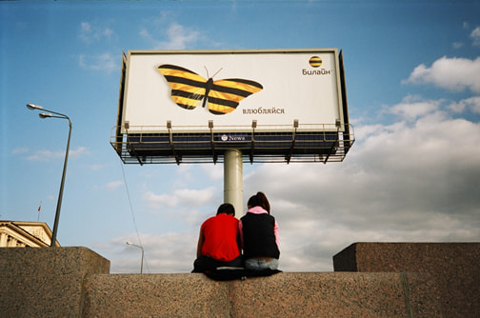

adapted from *Grammar Dimensions 3*

